**Problem_Statement3**

**----------------------------------------------------------------------------------------------**

**Inserting_data to the Book Table**

**insert into Books values('1', 'Let Us C', 'Yeshavant P. Kanetkar', '200');**

**insert into Books values('2', 'Thinking In Java', 'Thinking In Java', '300');**

**insert into Books values('3', 'Computer Networking', 'James F. Kurose', '250');**

**insert into Books values('4', 'Head First C#', 'Andrew Stellman', '400');**

**insert into Books values('5', 'What is HTML5?', 'Brett McLaughlin', '300');**

**insert into Books values('6', 'HTML5 in Action', 'Jeo Lennon', '569');**

**insert into Books values('7', 'OOP With C++', 'Balagurusamy', '308');**

**insert into Books values('8', 'C++:The Complete Reference', 'Herbert Schildt', '532');**

**insert into Books values('9', 'Head First SQL', 'Lynn Beighley', '450');**

**insert into Books values('10', 'SQL:The Complete Reference', 'James Groff', '667');**

**select *From Books;**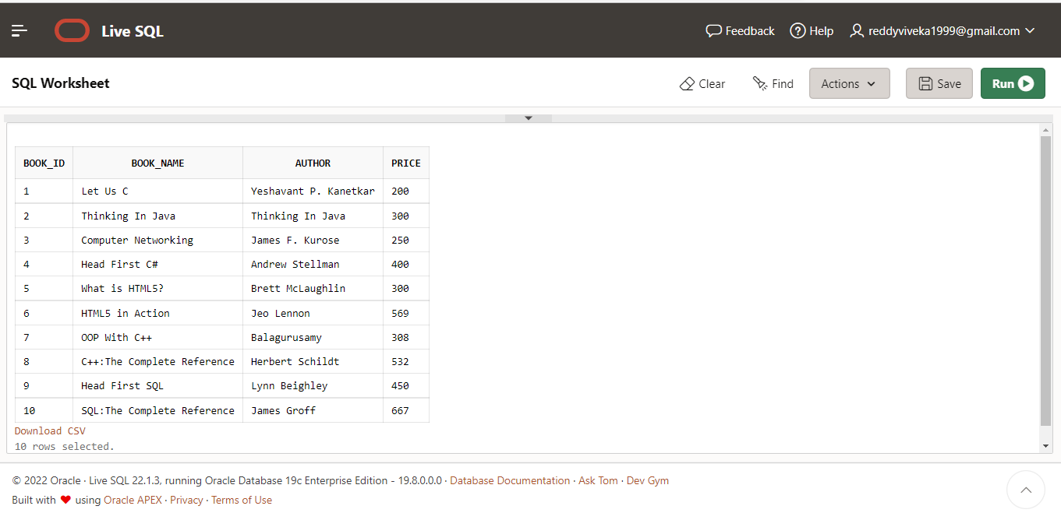

**Inserting_data to the Users Table:**

**insert into Order_details values ('1','3', 'Amith', '9673960407', 'Radhika Vihar', '2016-11-08', '3');**

**insert into Order_details values ('2','2', 'Mona', '875451395', 'Rakshak Nagar', '2016-11-08', '3');**

**insert into Order_details values ('3','7', 'Kavi', '7845127845', 'Rakshak Nagar Gold', '2016-11-08', '2');**

**insert into Order_details values ('4','8', 'Monalisa', '784512788', 'Banglore', '2016-11-08', '3');**

**insert into Order_details values('5', '3', 'Amol', '784575215', 'Wadganosheri', '2016-11-08', '3');**

**insert into Order_details values ('6','5', 'Amit', '78521868', 'Banglore', '2016-11-08', '2');**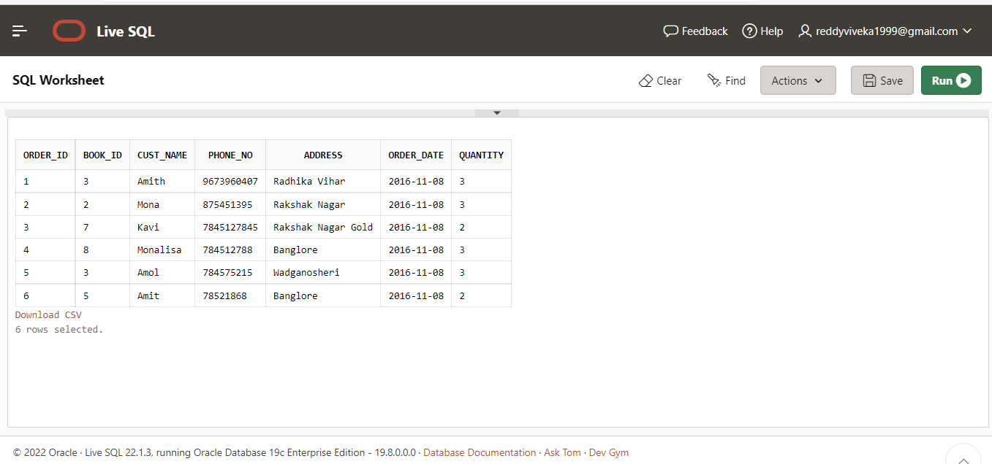

**Creating Users Table**

**---------------------------------------------------------------------------------------------------------------------**

**insert into users values('Amith', 'Wagholi', 'amit.mishra369@gmail.com', '9673960407', 'mona9Dutta', '2016-11-08');**

**insert into users values ('Hari', 'Chandan Nagar', 'hari39@rediffmail.com', '7845127421', 'Admin99@', '2016-11-08');**

**insert into users values ('Monalisa', 'Rakshak Nagar', 'mona9@gmail.com', '9878454503', 'pinaki9@', '2016-11-08');**

**insert into users values('Narendra', 'Rajpath', 'narendra17@pmo.nic.in', '8877990011', 'Delhi9%', '2016-11-08');**

**insert into users values ('Kavita', 'Rakshk Nagar Gold', 'kavi23@gmail.com', '9878521402', 'Alia8&', '2016-11-08');**

